

|  |  |  |
| --- | --- | --- |
| Iron Man Kalkaringi | Hemoglobin, red blood cell | Milpirri Festival, Lajamanu |
| Dance, counting beats | Baniyala Garrangali, Shark | Centralian Senior College |
| Banner Painting, art, visual | Jokes by Toad | Skinnyfish Road Safety |
| Film making competition | Warruwi Trickers, back flip | Mutitjulu, Don’t Worry |
| Music4Life |  |  |

**Note to teachers:**

As always, we are looking for feedback from teachers to ensure that these notes are providing genuine learning opportunities for students. We would also love input from teachers. If you have any suggestions for activities, or activities you have come up with for your class, please get in touch with us.

VAMPtv – Production team.

Rod Balaam

VAMPtv School Liaison

[Rodney.Balaam@ntschools.net](mailto:Rodney.Balaam@ntschools.net)

**EP54 -** http://web.ntschools.net/w/NTMS/Pages/Episodes.aspx?pbs=54&pid=4

**Series 4 Episode 54**

**Warning: Aboriginal and Torres Strait Islander readers should be aware that this document may contain images or names of people who have since passed away. Teachers should use discretion and sensitivity when using this content with their students.**

**Missing Words**

About, style, vitamin, think, meat, dancing, playing, piece, our, delicious, some, iron, entire, protecting*,* plane,

**RL 3.1** Communication

**L L3.3** Language structures and features

**Iron Man -** A new Hip Hop song from Kalkarindji.



This one has a message about drinking tea. Drinking tea with meals can decrease the amount of iron from food that the body can take in. This is especially a problem for pregnant woman, who need more iron to help the baby grow. Taking Vitamin C from fruit and fruit juices does reverse this and allow the body to absorb more of the iron from the food. Anyway, listen to the song, and work out the missing words!

All my boys, ________ down the street

Eating some meat and drinking ______ tea

Look out boys, drop the beat

Here come the ______ man

Come on boys, stop and ______

When you eat _______ you change your drink

Milk, water and a ________ of fruit

That’s the _______ if you wanna look cool

Yo, Yo we’re the Gurindji girls, here’s a song for the _______ world

Staying healthy, ________ sport

With this hip-hop we’re ______ to get taught

Bush tucker food has lot’s of iron

It’s__________ , we ain’t lying

From bush food, we get ________ C

With _____ dinner, we don’t drink tea

***Pre-chorus*** *- Run, run, as fast as you can, you can’t catch me I’m the iron man*

*I’m a deadly team, with vitamin C, ____________ my people, in Kalkaringi*

***Chorus*** *- I am the Iron man, oh yes I am, oh yes I am*

*Is it a bird or a ________ , that’s the man keeping the NIMIA away X 2*

**Activities to do on your own (or with a friend!)**

**Iron Man (cont)**

Hey everybody, listen to me

All my _______ in Kalkaringi

Here’s a _________message for you pregnant ladies

You need _______ iron, for your babies

When you’re having a feed, _______ is the plan

_______ with him, it’s the iron man

You find him in beef or kangaroo, fish, turkey, bush tucker too

Iron is important to keep ________ strong

But when you ______ tea it can all go wrong

Beware Mr T, he’s off his rocker

He is Iron man’s ________ blocker

Ironman needs mates to _______ him out

Vitamin C _________ a doubt

If you’re ________ weak, sick or slow

Put some iron in your______ , I’m telling you bro

***Pre-chorus*** *- Run, run, as fast as you can, you can’t catch me I’m the iron man*

*I’m a deadly _______, with vitamin C, protecting my people, in Kalkaringi*

***Chorus*** *- I am the Iron man, oh yes I am, oh yes I am*

*Is it a bird or a plane, that’s the man ________ the NIMIA away X 2*



* Iron is an essential part of the proteins that transport oxygen in the body.
* They transport oxygen (air) through the blood.
* Hemoglobin, the oxygen-carrying protein in red blood cells, accounts for about two-thirds of the iron in our body.

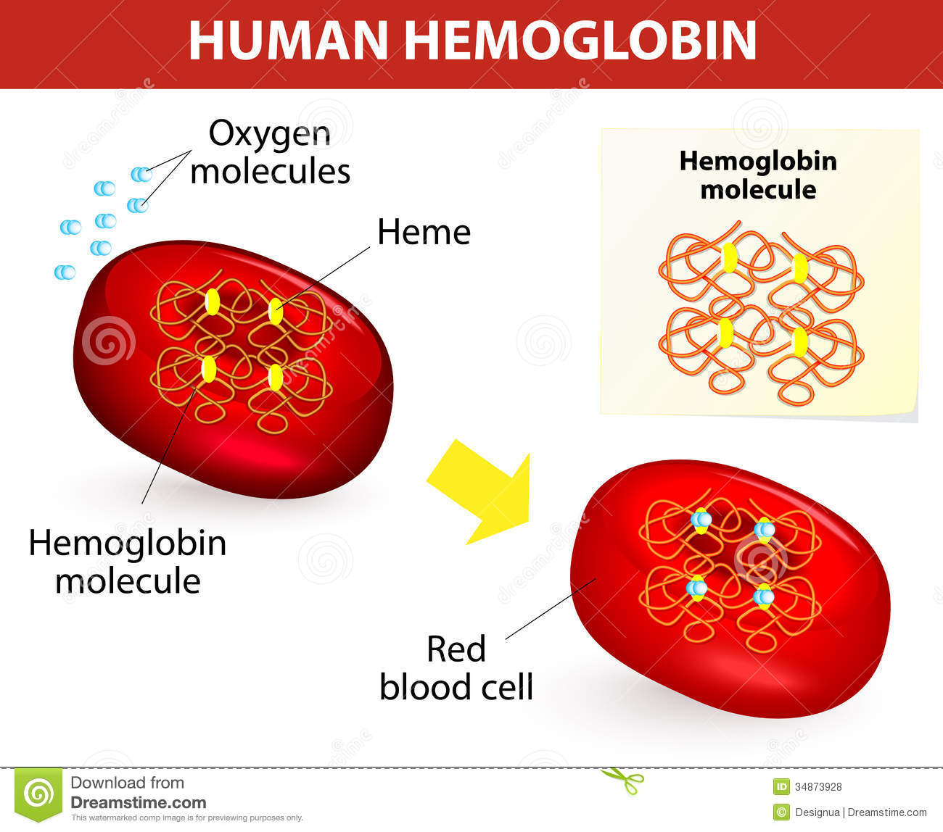

**Missing Words**

Family, biggest, blood, help, feeling, more, drink, without, this, Stick, *team,* diet, *keeping,* special

**RL 3.1** Communication

**L L3.3** Language structures and features

**RL 3.1** Communication

**W L 3.1** Communication **W L3.3** Language structure and features **SOC 3.4** Values, beliefs and cultural diversity

**MILPIRRI FESTIVAL**

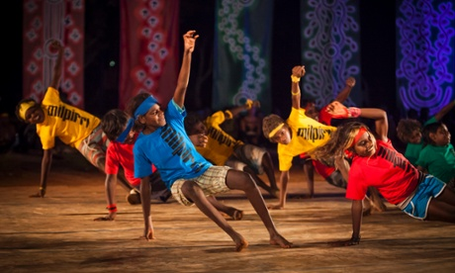

Milpirri is named after a storm cloud that brings rain to the desert when hot and cold air combine. The rain brings hope and new life.

Milpirri is a cultural celebration by the Warlpiri people who live on the edge of the Tanami desert in the NT. The festival is held in Lajamanu and this year the theme is from the Jarda-Warnpa ceremony. This Warlpiri “Fire” ceremony is associated with ‘making good’ and reconciliation. The festival features music, dance, ceremonies and painting and brings over 250 performers and artists together to celebrate

The first Milpirri Festival was held in 2005 to bring young people back to their culture. Rehearsing and performing with elders, passes culture, history and ideas on to younger members of the community.

TASK: Read the above information about the Milpirri Festival and answer the questions below in full sentences. 1. What is the Milpirri festival? _______________________________________________________________________ _______________________________________________________________________

2. What year was the first Milpirri Festival held? _______________________________________________________________________ _______________________________________________________________________

3. Why was the first festival held? _______________________________________________________________________ _______________________________________________________________________

4. What is the festival named after? _______________________________________________________________________ _______________________________________________________________________

5. What is the theme for the festival this year? ____________________________________________ ____________________________________________

**Activities to do With YOUR TEACHER**

**RL 3.1** Communication

**L L3.3** Language structures and features

**W L3.3** Language structure and features

**Activities to do With YOUR TEACHER**

**Milpirri – extension question**

In the article*, ‘Milpirri shows that black or white, we must understand the country we walk on’,* Wanta (Stephen) Jampijinpa Patrick says that Milpirri *is* “school”.

He lists the things that Milpirri teaches. Find the paragraph where he talks about this and write the list of the things that Milpirri teaches. If you do not understand all the words, use Google to find out what they mean! Hint ‘diligence’ means ‘careful and persistent work’

Find the article here: www.theguardian.com/commentisfree/2014/nov/01/milpirri-shows-that-black-or-white-we-must-all-understand-the-country-we-walk-on

Milpirri teaches the whole community about;

_____________________________________________________

_____________________________________________________

_____________________________________________________

_____________________________________________________

_____________________________________________________

_____________________________________________________

_____________________________________________________

Word definitions (what does the word mean!)

_____________________________________________________

_____________________________________________________

_____________________________________________________

_____________________________________________________

_____________________________________________________

Who wrote this article? ­­­­­­­________________________

How could that influence what the writer says?

_____________________________________________

_____________________________________________

Shark and Dolphin

Warruwi

**RL 3.1** Communication

**L L3.3** Language structures and features

**Dolphin vs Shark**



The students at Baniyala Garrangali School recorded this song. It is all about the idea to be good at school. Being good is not just about getting along with people and not making people upset, it also helps you learn! If something is hard, you keep on trying, you’ll get you know, if you stick to it!



|  |
| --- |
|  |
|  |

**Activities to do on YOUR own (or with a friend)**

**Lot’s of hard work and deep thinking in these pages, now it’s time to get colouring!**

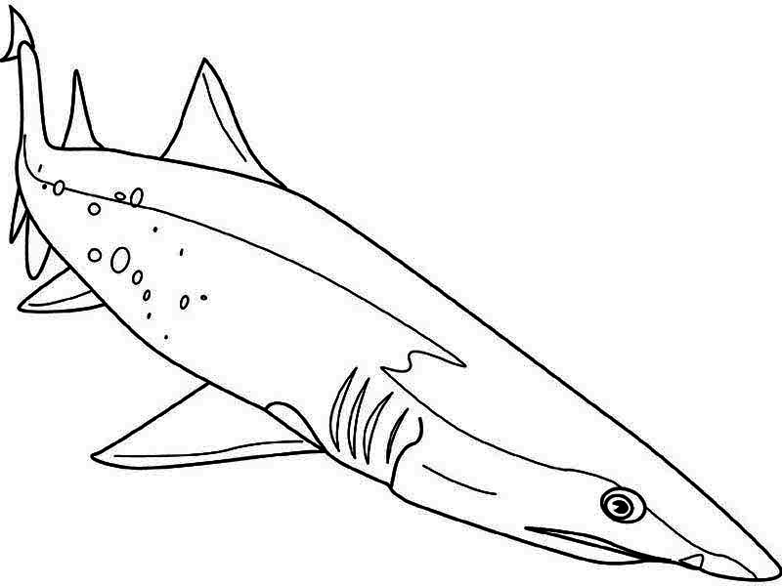

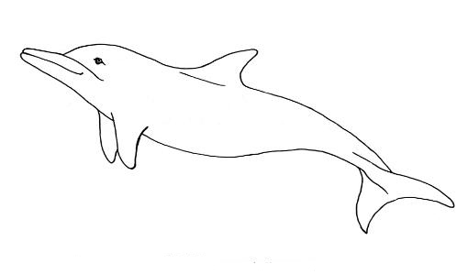

**RL 3.1** Communication

**SkP** Arts Skills and Processes

**Activities to do on YOUR own (or with a friend)**



**Don’t forget – This is your last chance to VOTE IN THE VAMPIES!**

Voting for the “People’s Choice” best video in the VAMPIES is online, cut and paste this link to have your vote, and your chance to win a VAMPtv T-Shirt!

<https://www.surveymonkey.com/r/MNBT2WM>

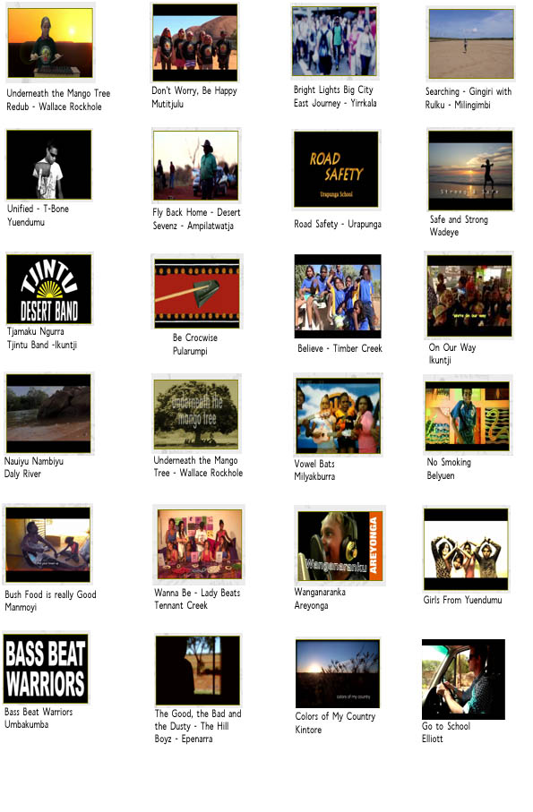



**LL 3.1** Communication

**RL3.1** Language structures and features

**W3.1** Text and Context

**kWL3.3** Language structures and features

**RL 3.1** Communication

**SkP** Arts Skills and Processes

**R L3.1** Language structures and features

**kWL3.3** Language structures and features