

|  |  |  |
| --- | --- | --- |
| Elliott, Go to school | Laynhapuy Hip Hop,homeland | Yirrkala, Baniyala, Gangan |
| Garthalala, IHHP | Dance lesson | Shout out Lajamanu |
| Member art work | Woolianna, Nganmarriyanga | Corella Creek |
| Film making Evellena Milimarr | Shepherdson, Garma trip | Lajamanu countdown |
| Searchin, searching, Gingiri | Milingimbi | Film making resource |

**EP53 -** http://web.ntschools.net/w/NTMS/Pages/Episodes.aspx?pbs=53&pid=4

**Note to teachers:**

As always, we are looking for feedback from teachers to ensure that these notes are providing genuine learning opportunities for students. We would also love input from teachers. If you have any suggestions for activities, or activities you have come up with for your class, please get in touch with us.

VAMPtv – Production team.

Rod Balaam

VAMPtv School Liaison

[Rodney.Balaam@ntschools.net](mailto:Rodney.Balaam@ntschools.net)

**Series 4 Episode 53**

**Warning: Aboriginal and Torres Strait Islander readers should be aware that this document may contain images or names of people who have since passed away. Teachers should use discretion and sensitivity when using this content with their students.**

**RL 3.1** Communication

**L L3.3** Language structures and features



All right listen up everyone; it’s time to wake up for school, wakey! wakey!

The students of Elliott School made this song with Monkey Marc and Barkly Regional Arts. Watch the video and fill in the missing words.

**Go To School**

My name is Ebony and I like _______

When I _______ I put my clothes in the locker

My ______ is Carlos and I like my Times tables

My favourite is 5, with my ______ enabled

Hey I’m Jacob I’m a basketball man

I dribble and I ________ as fast as I can

My name is Leroy Jones and I like science

I like playing sports, and I _______ violence

I am Wallen, and I like ________

And ______ school, I go horse riding

*Chorus*

Go to School Go to School

And _______ to your mummy

Go _______ go ahead, don’t be a dummy

Daddy and Uncle trying to _______ you up

________ your bed, listen up listen up X2

**Activities to do on your own (or with a friend!)**

**Missing Words**

Soccer, listen, reading, dribble, wake, mind, name, hate, ahead, after, finish, shaking

**RL 3.1** Communication

**L L3.3** Language structures and features

(Yeah listen up you mob, go to school)

I woke up in the ________ and I put on my clothes

I walked _______ and it was cold

My mum said, “hey boy put on a jumper

And learn your times tables and your ______ of numbers”

When I got to school, I saw my _________

Then the school bell ______ and the day begins

It was my __________ lesson, it was out of sight

So I opened my book and began to write

*Chorus*

One day my friend was being bad

He was ________ in the toilets and making me mad

Then a fella I ______ was swearing a lot

So a teacher came along and told him off

The youngest kid in class is _______ lying

Sometimes he ________ girls and now they’re crying

Some kids they muck ________ , they are always fighting

But I don’t care coz I’m always learning

Every day at school, I ______ to listen

And _______ and learn and learn, get more education

If I come ________ I could go to college

My ________ will get big with so much knowledge

Yeah, Listen up, go to school

*Chorus*



**Missing Words**

rang , book, morning, knew, come, outside, friends, favourite, teases, everyday, around, brain, learn, kissing, always

**Hip Hop Dance**

Dance is great fun to do and watch. It moves with music and it can also tell a story!

Body language is a language that people can understand even if they don’t know words! Gesture, poses and expressive movement communicate feelings, thoughts and ideas.

Check out these pictures to see what they communicate. One is happy, one is sad!

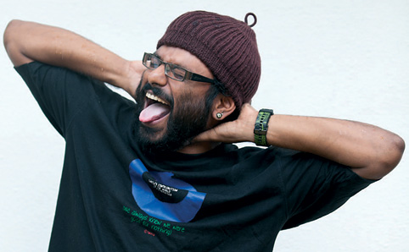 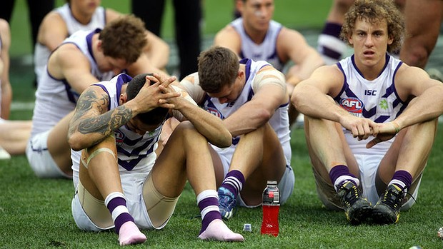

Body Language and Movement, or dance, can express and communicate!

Try retelling a simple story using Body language/movement. You can pick whatever story you like, or make one up of your own (going to the shop or going hunting) but here, we will use the example story of a nursery rhyme. If this is too baby for your class, pick your own!

We have chosen ‘Old MacDonnel Has a Farm’ as you can watch the Yolngu version of this by Gilbert Dhamarrandji! on VAMPtv – it’s number 1 spot on Episode 34 <http://web.ntschools.net/w/NTMS/Pages/Episodes.aspx?pbs=34&pid=3>

It is also ion the members site

<http://vamptv.ning.com/video/yolngu-old-mcdonald>

You can use this song as the music!

The basic story is;

*Old McDonald had a farm, E-I-E-I-O*

*And on his farm he had a cow, E-I-E-I-O*

*With a "moo-moo" here and a "moo-moo" there*

*Here a "moo" there a "moo"*

*Everywhere a "moo-moo"*

*Old McDonald had a farm, E-I-E-I-O*

Activity adapted from;

http://www.pbs.org/wnet/dancin/resources/lesson_plan-d1.html

http://artsonline2.tki.org.nz/resources/lessons/dance/poemdance/index_e.php

**RL 3.1** Communication

**L L3.3** Language structures and features

**CrA** Creating Arts Ideas

**Activities to do With YOUR TEACHER**

**RL 3.1** Communication

**L L3.3** Language structures and features

**CrA** Creating Arts Ideas

**Res** Arts Responses and Analysis

**Activities to do With YOUR TEACHER**

**In this activity you will need to;**

* Think about how characters move
* Invent movements and gestures to show some of the actions in the story.
* Retell the story using your own invented movements.

**1st Stage**

1. Who are the characters? In this example it is the old man, and the cow. Divide the class. Half can be the old man, the other half the cows
2. Where is the story? On the farm. It is outside, is there a fence for the cow?
3. How will the characters move to show what they are?

Discuss how you would move to show an old man.

Discuss how you would move to show a cow.

**2nd Stage**

Get students to walk a line down the room as the old man. What body language, what speed, how big the steps, loose and fluid or jerky.

Now the Cow. Again, what posture (body shape), what kind of steps, what speed and style of movement!

When you do this you should think about the BEAT of the song. Make your Characters move in time with the music! (But the old man, if he is slow, could move every 2 or 4 beats)

When you have worked out your movement to show your character, practice it, so you can produce the same movement each time. When you can, you are ready to run the Dance!

The important thing to remember is to HAVE FUN. Let yourself ‘let go’ and really become an oldman or a cow. If you do that you’ll enjoy yourself more and the ‘dance’ will look better!

**3rd Stage**

When you have finished, it is important to talk and think about what you just did. Answer these questions.

1. Was it easy to see what each character was in this movement/dance?

_________________________________________________________________

1. Did the piece retell the story successfully?

_________________________________________________________________

3 Was it possible to make the movements the same way each time?

_________________________________________________________________ 4 What could you do to improve the piece?

_________________________________________________

_________________________________________________













**Film making.**

Evellenna from Elcho Island made a ***documentary*** film about her and her school friends going to the GARMA Festival this year.

***Documentary*** is the style of film that tells a REAL story, it is a DOCUMENT of something that really happened.

Sometime this style of film is produced to show people the FACTS to educate them or make them think about things in a different way, so the purpose is actually to PERSUADE people, by informing them.

All films use the same ‘building blocks’. They all are made up of series of moving images. These are called SHOTS.

The Establishing or Long Shot The High Angle Shot

The Low angle shot The medium Shot

The Close-up Point-of-View Shot

There are more including the extreme close-up, the Point Of View,

|  |
| --- |
|  |
|  |
|  |

**RL 3.1** Communication

**L L3.3** Language structures and features

**Skp** Arts Skills and Processes

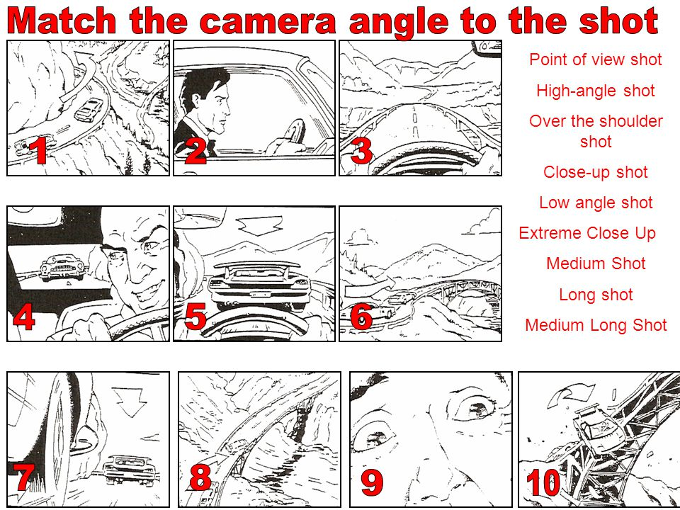

Match the number of the picture with the type of shot you think it is!

**1 ______________________ 2 _______________________**

**3 ______________________ 4 _______________________**

**5 ______________________ 6 _______________________**

**7 ______________________ 8 _______________________**

**9 ______________________ 10 ______________________**

Point of view shot -The audience sees as if they were in the action, they see what the character sees.

High-angle shot – Shot from above eye-level. Could suggest character’s weakness or isolation. The audience is in a powerful position.

Over the shoulder shot - Focuses the audiences attention on one character

Close-up shot - Concentrates attention. Shows characters emotion.

Extreme close up shot - Audience in intimate relationship. Shows a character’s intimate feelings.

Low angle shot - Suggests character’s bigness, strength or dominance. Audience in weak position.

Medium Shot - Situates character in immediate environment, yet still shows emotion.

Long shot - Shows the location of the shot.

More on shots and camera movements: https://www.youtube.com/watch?v=ICcE72RwEyc

**RL 3.1** Communication

**L L3.3** Language structures and features

**Res** Arts Responses and Analysis



Voting for the “People’s Choice” best video in the VAMPIES is online, cut and paste this link to have your vote, and your chance to win a VAMPtv T-Shirt!

<https://www.surveymonkey.com/r/MNBT2WM>



**Activities to do on YOUR own (or with a friend)**

**LL 3.1** Communication

**RL3.1** Language structures and features

**W3.1** Text and Context

**kWL3.3** Language structures and features

**RL 3.1** Communication

**SkP** Arts Skills and Processes

**R L3.1** Language structures and features

**kWL3.3** Language structures and features

For a further resource on aspect of Film making called ‘Making Movies’ put out by the IP Awareness Foundation click on the Teachers’ Resource pdf link.[http://www.nothingbeatstherealthing.info](https://webmail.ntschools.net/owa/redir.aspx?C=zmuTz6ujjkuHqaZbDMZLPDThR2310NFIKjwaqRiHC8AYGE2YTFOjXjz6oDaRb0zmhytQMWKsIK8.&URL=http%3a%2f%2fwww.nothingbeatstherealthing.info).





**LL 3.1** Communication

**RL3.1** Language structures and features

**R B2.3** Language structures and features

**kWL3.3** Language structures and features

**Activities to do on YOUR own (or with a friend)**