

|  |  |  |
| --- | --- | --- |
| Kintore Colours of my Country | Trachoma resources | Dance careers research |
| Warruwi, Create beats | Art, drawing, Keith Haring | Joke by Toad Woolianna |
| Kids on the run Alekarenge | Ali Curung Desert Culture | Shout Out Areyonga |
| Areyonga is great | Feeling Alright, Shepherdson | Chord diagrams guitar ukulele |
| Strumming pattern | Garma, music notation | Rhythm reading chord charts |
| Gurindji Man, Kalkaringi | Karungkani Band | Word puzzle |

**EP52 -** http://web.ntschools.net/w/NTMS/Pages/Episodes.aspx?pbs=52&pid=4

**Note to teachers:**

As always, we are looking for feedback from teachers to ensure that these notes are providing genuine learning opportunities for students. We would also love input from teachers. If you have any suggestions for activities, or activities you have come up with for your class, please get in touch with us.

VAMPtv – Production team.

Rod Balaam

VAMPtv School Liaison

[Rodney.Balaam@ntschools.net](mailto:Rodney.Balaam@ntschools.net)

**Series 4 Episode 52**

**Warning: Aboriginal and Torres Strait Islander readers should be aware that this document may contain images or names of people who have since passed away. Teachers should use discretion and sensitivity when using this content with their students.**

**RL 3.1** Communication

**L L3.3** Language structures and features

**Missing Words**

look, listen, water, work faces, make, see, strong you, germs country, eyes



This great new song from Kintore has a good message about the eye disease called trachoma, and how to keep our eyes strong! Watch the song and see if you can fill in the missing words

***Colors of My Country***

All you mob got to ______ up to what I say (Listen to what I say)

Got to keep our _______ clean everyday (everyday)

Blow your nose, wash your hands with soap and ________

Let’s ______ trachoma everyones’ business

My eyes see, the color of my _________

I see you, you _____ me

Together with _______ eyes

All you mob got to _______ out for what you do

Germs can spread, between me and ______

If we keep, ourselves clean, _______ together

Keep the _______, from our _______, forever

Chorus

**Activities to do on your own (or with a friend!)**

**RL 3.1** Communication

**L L3.3** Language structures and features

**CrA** Creating Arts Ideas

**Trachoma** is a serious disease that can ruin your eyesight. For more

resources; <http://iehu.unimelb.edu.au/the_trachoma_story_kit/free_kit_resources>



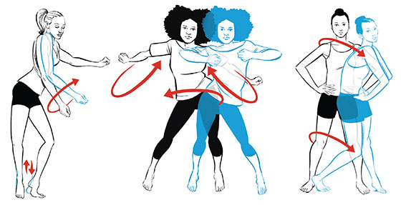

Dancing is fun! We can see from The GBI Supercrew how much fun they had. It is also something that requires hard work, persistence, strength and agility. Something the GBI Supercrew also had!

At VAMPtv we love dance. It is something you can do for fun with your friends. It is something you can study and at school and university. It is a creative outlet that keeps you fit, and, it is something that you can do as a career. Here is a list of some of the occupations (jobs) that relate to dance.

Use the internet to write a description of these jobs. Type the word, then ‘job description

Choreographer _______________________________________________________

_______________________________________________________

Dancer _______________________________________________________

_______________________________________________________

Dance Teacher _______________________________________________________

_______________________________________________________

Dance Therapist _______________________________________________________

_______________________________________________________

**Activities to do With YOUR TEACHER**

**RL 3.1** Communication

**L L3.3** Language structures and features

**CrA** Creating Arts Ideas

**Activities to do With YOUR TEACHER**



Now to have some fun dancing! You will need a clear space, and don’t feel worried – there is no wrong way, have fun, no shame! It will probably help to have some music or a rhtyhm to dance to. You can make up a simple beat using [www.beatlab.com](http://www.beatlab.com)

Find a space where you have room to move then, to the beat, *Dance these words and feel how the energy of the room changes!*

Shake the space

Jab the space

Push the space

Poke the space

Shatter the space

Tickle the space

Slash the space

Press the space

Swat the space

Dodge the space

Strike, shove, and squeeze the space

Caress, mooch, and mould the space

FREEZE in space.

Use this activity to:

* physically warm and focus students for dance activity
* increase students’ dance and language vocabulary
* encourage students to develop their own ways of moving
* develop student confidence in exploring movement and sharing the general dance space safely
* practically explore action words through movement using a variety of energy levels and movement qualities.

http://artsonline2.tki.org.nz/resources/lessons/dance/poemdance/index_e.php

http://artsonline2.tki.org.nz/resources/lessons/dance/poemdance/index_e.php

**RL 3.1** Communication

**L L3.3** Language structures and features

**CrA** Creating Arts Ideas

**Activities to do With YOUR TEACHER**

**Dance programs can develop good all-round skills!**

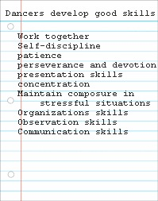

**Art Project!**

Look at the people in this picture by New York artist Keith Haring

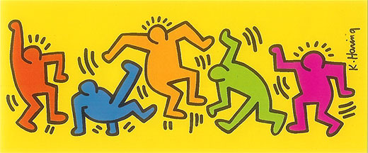

What are they doing? Dancing? Sitting? Playing? Now it’s your turn to become a Haring model. Make some funny poses with your body. Think about where your arms and legs are. Next draw stick people on a piece of paper that look like some of the poses you made. Then draw an outline around your stick people and color them in. You have Haring inspired art! <http://www.kidcreatestudio.com/tag/projects/>

You can have a lot of fun at the Keith Haring website: www.haringkids.com

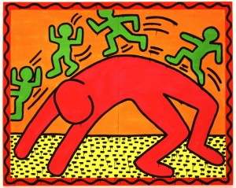

**RL 3.1** Communication

**L L3.3** Language structures and features

**Skp** Arts Skills and Processes



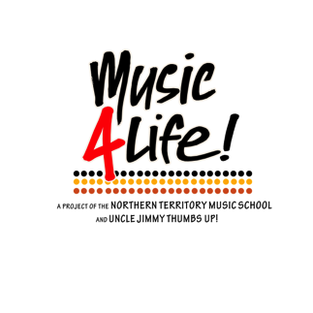

The Students from Shepherdson College at Galiwin’ku went to Garma and worked on their original song. Here are the lyrics and chords, perhaps you can learn to play it!

Feeling Alright

You can take away my money

You can take away my shoes

But you wont take what I'm feeling

That's something I can't lose

Feeling alright feeling alright ,I'm feeling alright.

I look out at the ocean

The salt is in the air

The sun is painting pictures

The wind is in my hair

I'm feeling alright feeling alright, I'm feeling alright.

Dhakay nhama manymak miritirr  (Chorus – repeat)

Verse

|  |  |
| --- | --- |
| **Em / / /** | **Em / / /** |
| **C / / /** | **C / / /** |
| **Am / / /** | **Am / / /** |
| **Em / / /** | **Em / / /** |

chorus

|  |  |
| --- | --- |
| **C / / /** | **Am / / /** |
| **Em / / /** | **Em / / /** |

If you can’t remember how to read this – check Teachers Notes 51!

**Ukulele Chords**



The strumming pattern is funky!

You play down on the one and two beat, then a fast strum with ups and downs and rests!

It is called *syncopated*, as the rhythm of the strumming goes both off and on the beat.

Below is the strumming pattern in musical notation.

D stands for Down

U stands for U

It looks complicated, but listen to the song and you’ll get the idea

**RL 3.1** Communication

**L L3.3** Language structures and features

**Skp** Arts Skills and Processes



**Guitar Chords**









Voting for the “People’s Choice” best video in the VAMPIES is online, cut and paste this link to have your vote and have the chance to win a VAMPtv T-Shirt!

<https://www.surveymonkey.com/r/MNBT2WM>

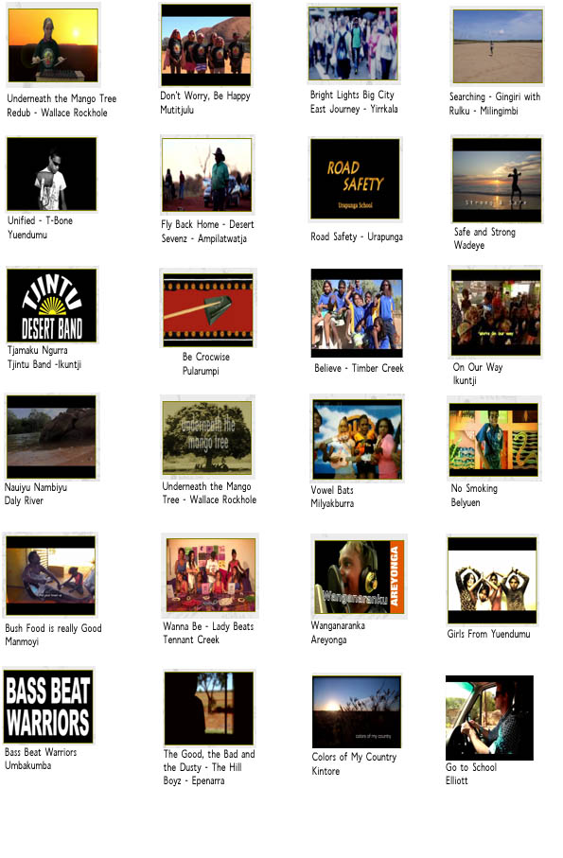

**Activities to do on YOUR own (or with a friend)**

**LL 3.1** Communication

**RL3.1** Language structures and features

**W3.1** Text and Context

**kWL3.3** Language structures and features

**RL 3.1** Communication

**SkP** Arts Skills and Processes

**R L3.1** Language structures and features

**kWL3.3** Language structures and features

**LL 3.1** Communication

**RL3.1** Language structures and features

**R B2.3** Language structures and features

**kWL3.3** Language structures and features

d 

Fill in the missing letters! You can make a word out of these letters!

____ ____ ____ ____ ____ ____

e

i

F

o

p

i

r

e

o

R

c

i

o

C

C

a

m

e

r

r

e

m

a



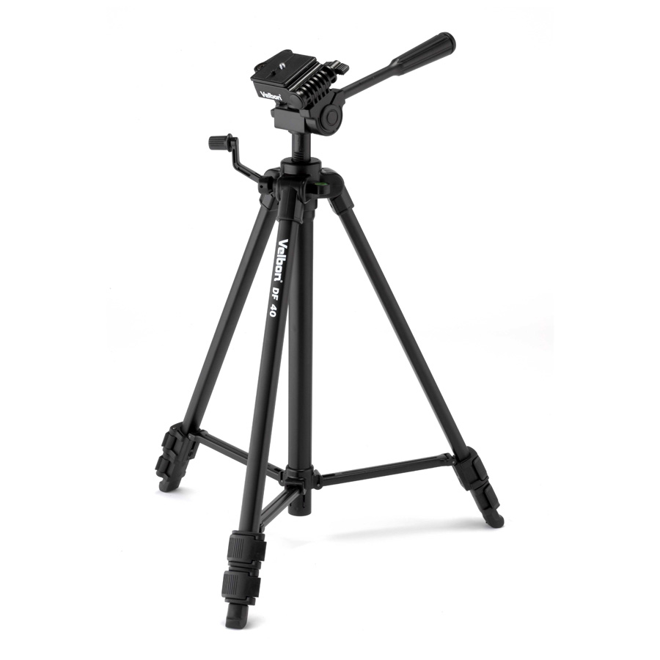

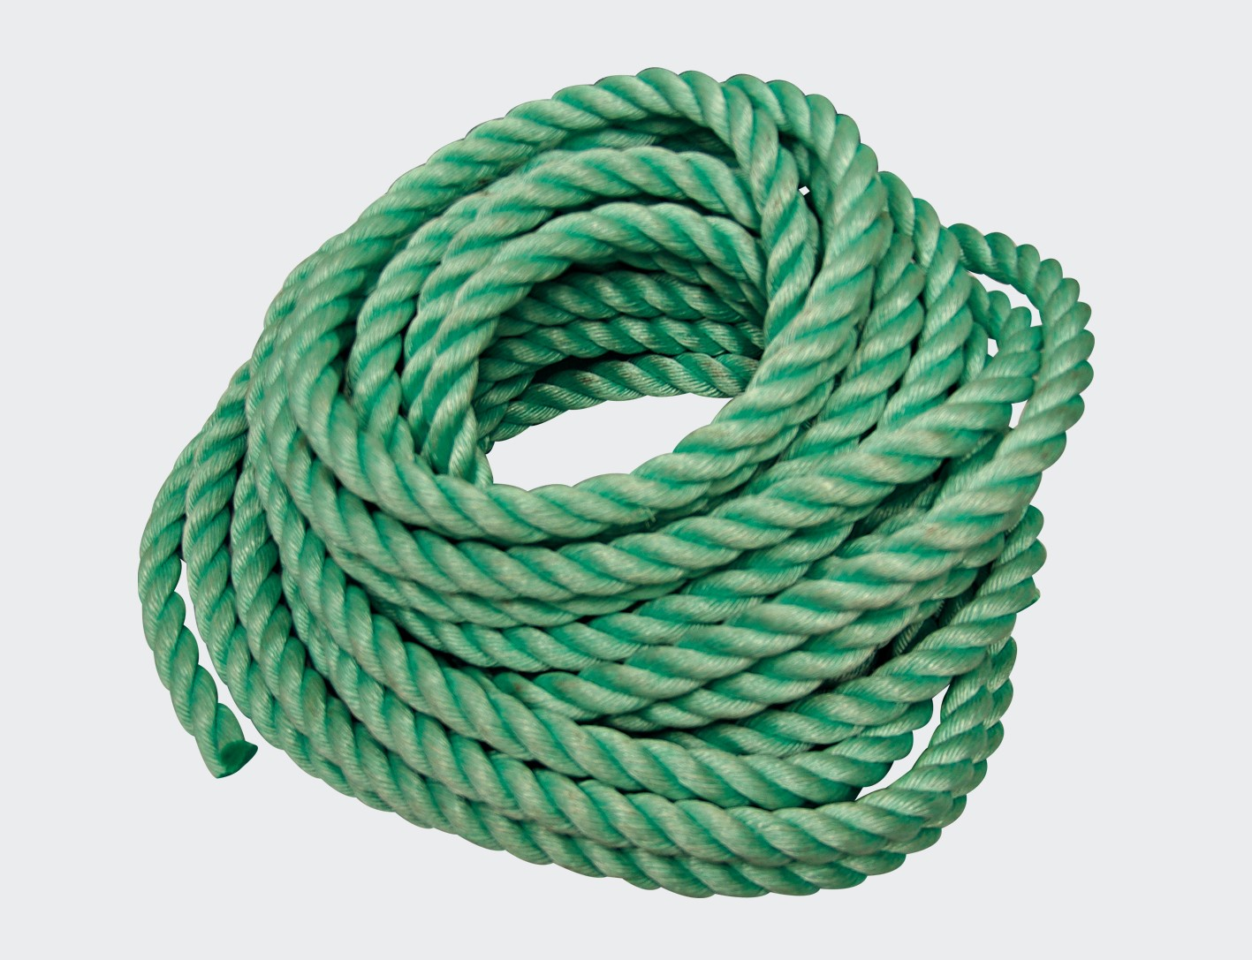

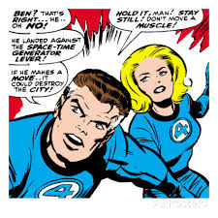

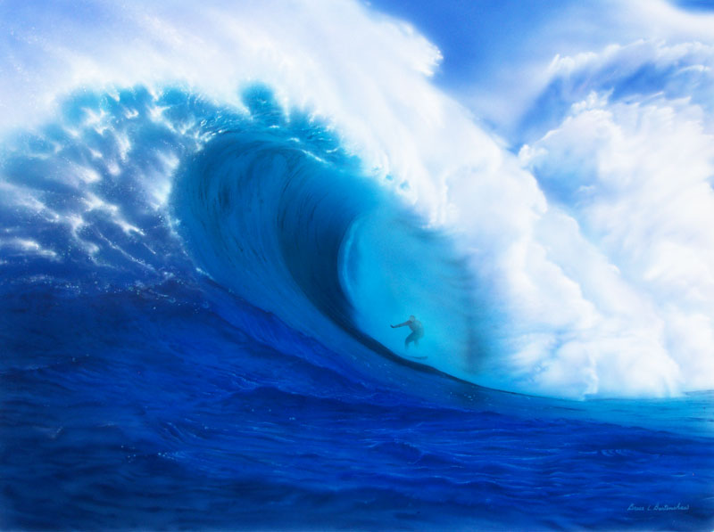



C

e

a

W

**Activities to do on YOUR own (or with a friend)**